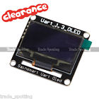**SainSmart 1.3" TTL UART 128X64 OLED LCD Display For Arduino**

**SainSmart 1.3" TTL UART 128X64 OLED LCD Display For Arduino Raspberry Pi ARM PIC**

**Overview**

OLED is the newest display technology in market now, as same as the modern OLED TV (Not LED TV, it use LCD with LED back-light), it can emitting light by it self, no back-light needed, so it's good for battery powered electronics, the maximum supplied current we test is: 18mA when all dots lighting.

**Did you:**

1, Hate to write code to drive OLED?

2, Don't have enough I/O pins to connect with OLED?

3, Don't have enough memory in your MCU to store FONT data?

4, Have special characters to display?

This unique adapter is your solution, it is for any kind of micro-controller, will save lots of memory space and I/O resource on your project, with the easy remember commands or Arduino lib, you can use OLED in couple of minutes! Draw character/line/circle/rectangle just cost less than 10 bytes of memory!

**Specification**

* Wide viewing range, almost 180 degree from left to right and up to down, you may know the modern LED TV now, this screen is made by same techno ledge, Better than LCD.
* Integrated 50MHz **ARM Cortex-M0 8KROM,2KRAM** MCU to process your command and graph engine
* Wide voltage working range: fit all 3.3V and 5V application.
* Save lots of the I/O resources: these products only need 1 to 3 I/O pins from your controller that depends on the communication type you want.
* Easy to use: the commands sending to products are easy to remember and understand.
* Using user fonts function, you can display any graphs or characters in any language
* These products already integrated graphic functions such as: draw line/rectangle/circle/image, send few bytes of instruction to products, it will do it for you, that also save your lots of code space
* You can display contents in 4 different directions: 0º, 90º, 180º, 270º(clockwise) on same screen, the product will map the coordinate accordingly.

**Note: We will provide you all round technical support after your purchase. Including the datasheet and the project files. We have issued our own APP for sainsmart TTL OLED LCD**

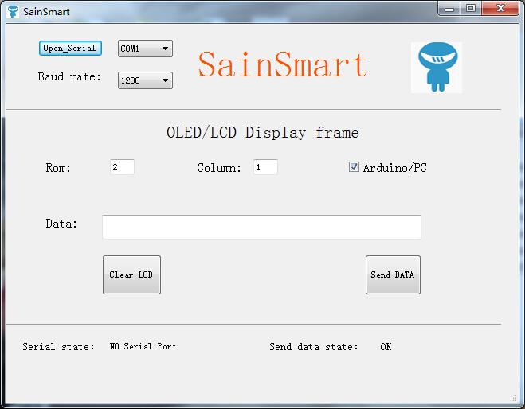

**FEATURES**



* Power Supply: 3.3V to 5V
* Power consumption: maximum 20mA when all dots light on
* Communication mode: UART
* Receiving buffer: 100 bytes
* Work with all micro-controller and microprocessor
* Communication signal can work on 3.3V and 5.0V TTL
* Default setting: UART baud 9600bps
* Pixels: 128x64, high bright self light emitting
* Simple command sets, easy to remember
* Simple graphic engine integrated

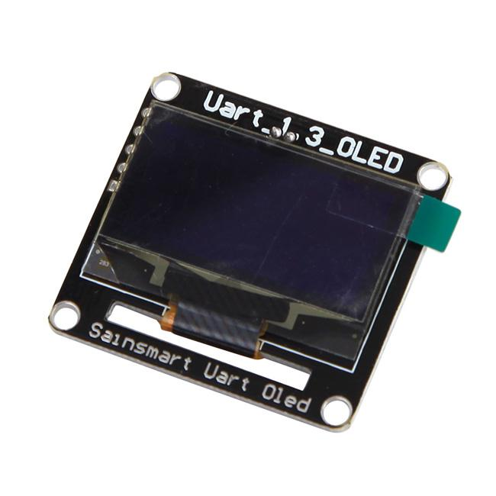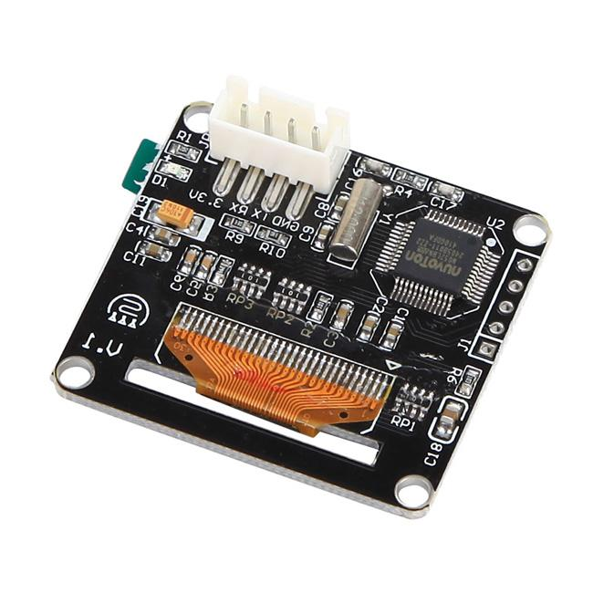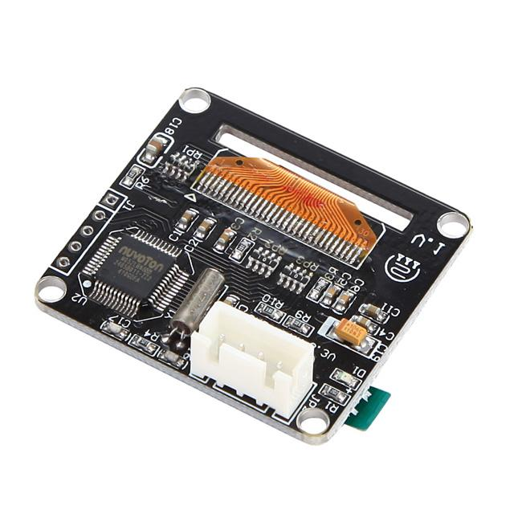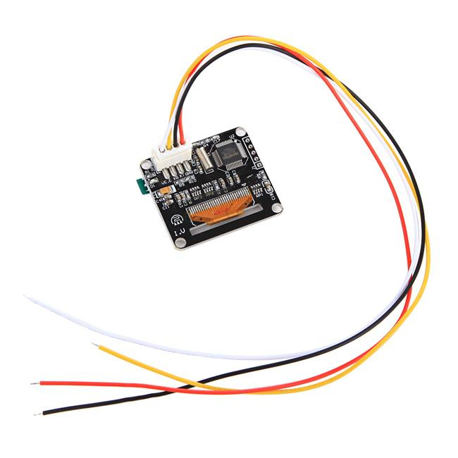

**Package List**

1XSainSmart 1.3" TTL UART 128X64 OLED LCD Display For Arduino UNO R3 Raspberry Pi

